Full Git Workflow Code (Step-by-Step)
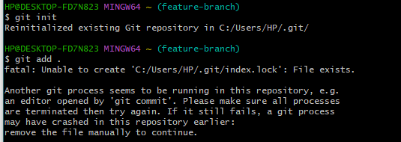
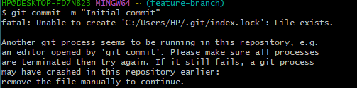
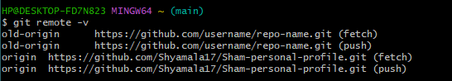
Step 1: Local Setup — Full Code
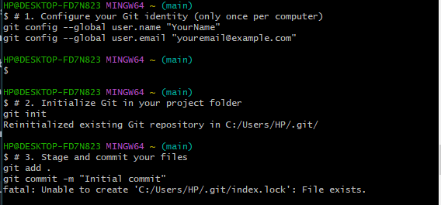
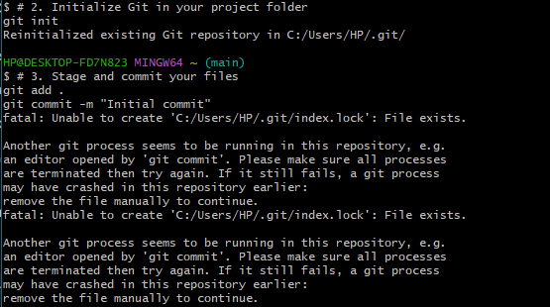

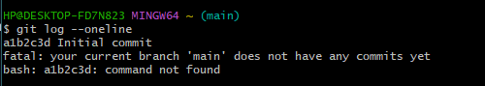

🔹 Step 2: Show Remote Linking
📸 Screenshot: Output should show:

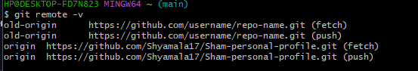

🔹 Step 3: Show Push to GitHub
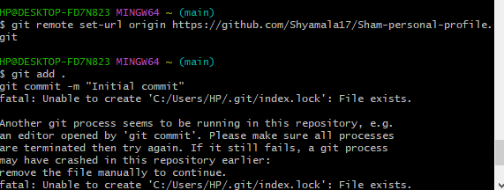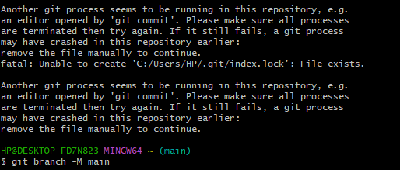

🔹 Step 4: Show Branching & Merging

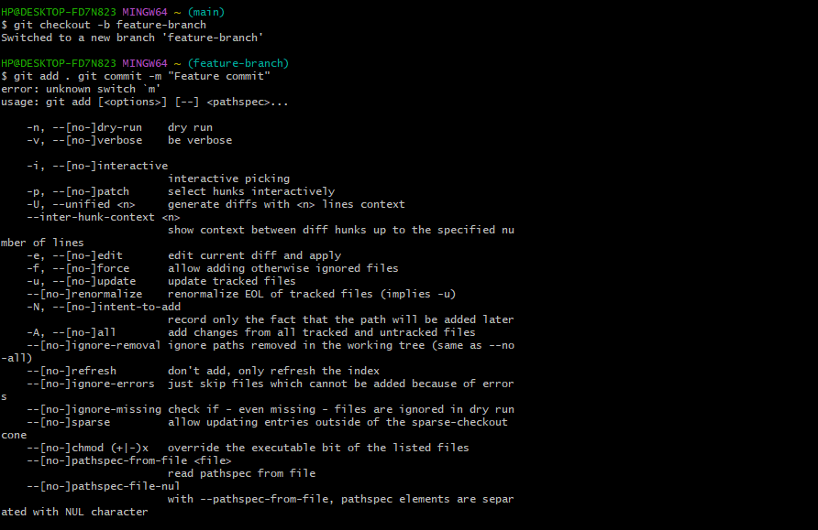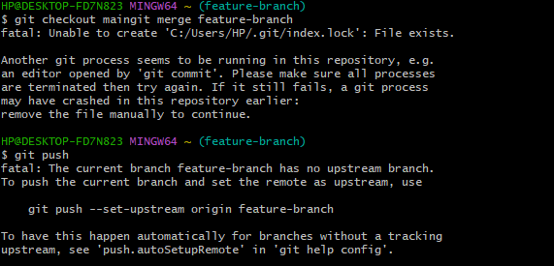
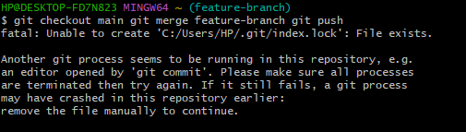

🔹 Step 5: Show Rollback Practice
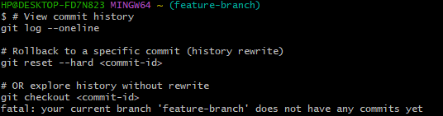

How to Show GitHub Repository Link in Deliverables
- Copy the repository URL from your GitHub repo page. Example:
Code
https://github.com/Shyamala17/Sham-personal-profile

- Include it in your documentation/report under a section like:
- Repository Link
- GitHub Project URL
- Source Code Location
- 3. Format it cleanly so it stands out:
GitHub Repository Link:
GitHub Repository Link: https://github.com/Shyamala17/Sham-personal-profile
markdown
## GitHub Repository Link
[Sham-personal-profile](https://github.com/Shyamala17/Sham-personal-profile)

GitHub Repository Link:
https://github.com/Shyamala17/Sham-personal-profile

